Day 7

**Day 7**

1. Show employee number, Sales Person (combination of first and last names of employees), unique customers for each employee number and sort the data by highest to lowest unique customers. Tables: Employees, Customers

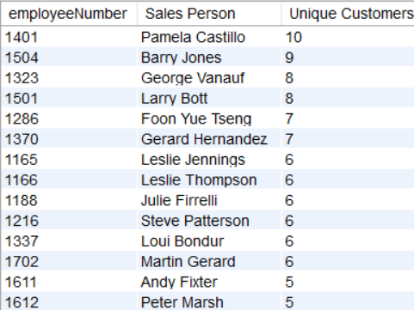

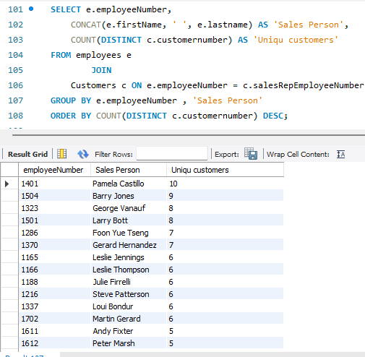

1. Show total quantities, total quantities in stock, left over quantities for each product and each customer. Sort the data by customer number.

Tables: Customers, Orders, Orderdetails, Products

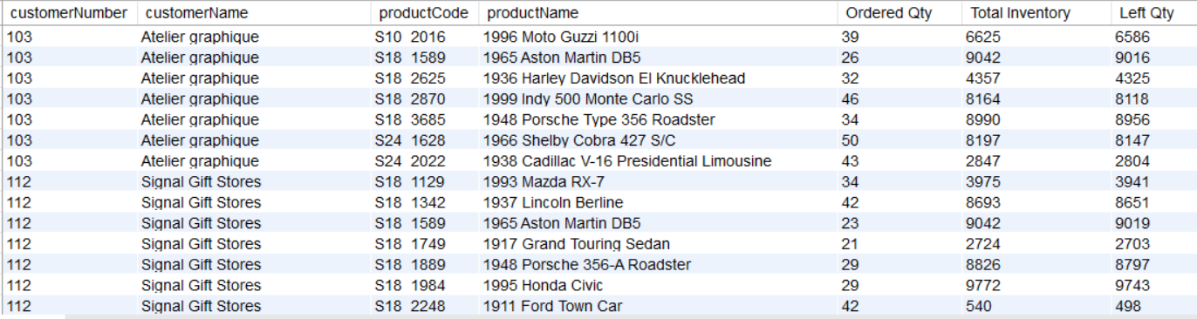

**Ans)**

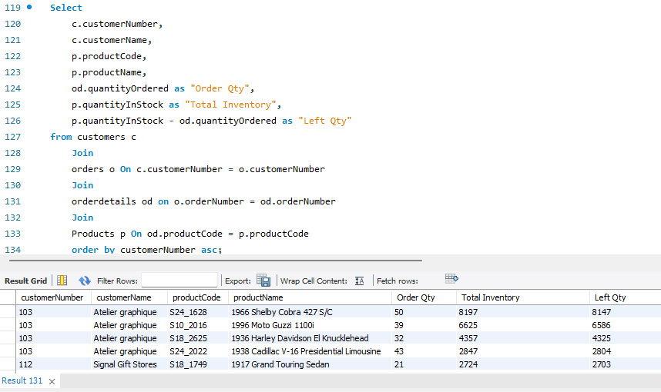

Result Set:

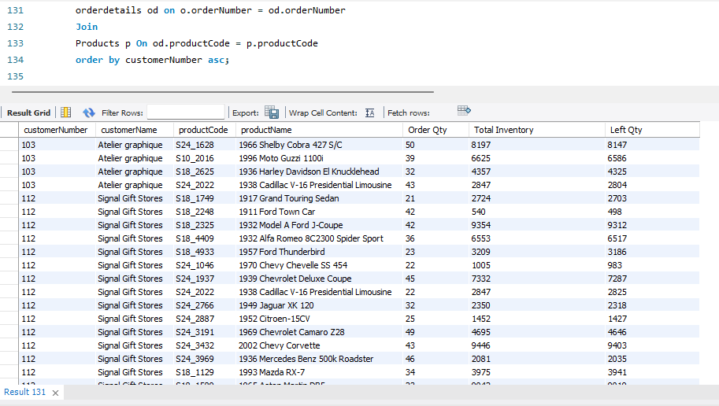

1. Create below tables and fields. (You can add the data as per your wish)

* Laptop: (Laptop_Name)
* Colours: (Colour_Name)

Perform cross join between the two tables and find number of rows.

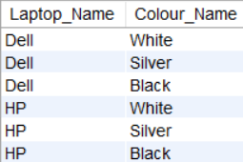

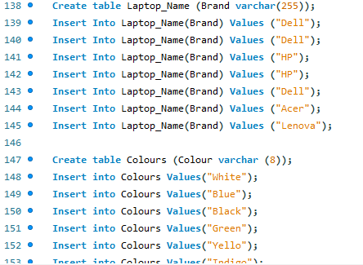

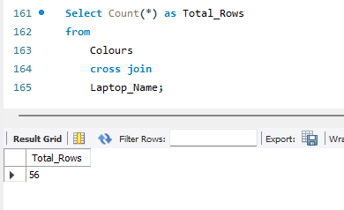

1. Create table project with below fields.

* EmployeeID
* FullName
* Gender
* ManagerID

Add below data into it.

INSERT INTO Project VALUES(1, 'Pranaya', 'Male', 3);

INSERT INTO Project VALUES(2, 'Priyanka', 'Female', 1);

INSERT INTO Project VALUES(3, 'Preety', 'Female', NULL);

INSERT INTO Project VALUES(4, 'Anurag', 'Male', 1);

INSERT INTO Project VALUES(5, 'Sambit', 'Male', 1);

INSERT INTO Project VALUES(6, 'Rajesh', 'Male', 3);

INSERT INTO Project VALUES(7, 'Hina', 'Female', 3);

Find out the names of employees and their related managers.

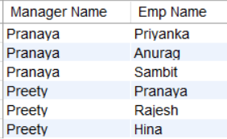

**Ans)**

